SIMATS ENGINEERING (SAVEETHA SCHOOL OF ENGINEERING)
Department of Computer Science and Engineering

ASSESSMENT TOOL 1 – Coding Challenge Task

Course Code: | CSA06 | Course Title: | Design and Analysis of Algorithms
CO Assessed: | CO4: Articulation (BL4, BL5) | Assessment: | Assessment Tool 1 – Coding Challenge Task
Weightage: | 40% of CIA | Total Marks: | 100
CO4 Statement: | Solve optimization problems using dynamic programming and greedy strategies.
Student Name: | N.Srinivas | Reg. No.: | 192372358
Section / Batch: | CSE(AI) | Date: | 20-08-2026

Instructions to Students
- Answer the following question. Total Marks: 100.
- Carefully analyze the given questions.
- Write clear code for the given problem.
- Analyze the Time complexity and Space complexity of your code using dynamic programming and greedy strategies

Question Type | Focus Area | Questions
Coding Challenge Task | Focus on Code and analyze optimization problems using dynamic programming and greedy strategies | Q1

SECTION A – Coding Challenge Task

Code of Conduct
I N.Srinivas(192372358) (Name / Reg No) certify that this submission is my original work and that I have adhered to the guidelines specified for this assessment. I understand that any violation of academic integrity rules will result in disciplinary action.
Signature of the Student: _N.Srinivas________________________

RUBRICS FOR CALCULATION

Coding Challenge Task

Criteria | Weightage | Level 4 (Exemplary) | Level 3 (Proficient) | Level 2 (Developing) | Level 1 (Beginning)
Problem Understanding | 20% | Clearly understands problem constraints, edge cases, and competitive requirements | Understands  problem with  minor gaps in constraints | Partial understanding; misses key constraints | Misinterprets problem or constraints
Algorithm | 25% | Selects optimal algorithm with best time and space complexity for  competitive constraints | Uses efficient algorithm with  minor scope for improvement | Uses basic/inefficient approach | No clear algorithmic approach
Code Implementation | 20% | Writes correct, efficient, and clean  code that passes all constraints | Code works with minor errors or inefficiencies | Partially correct code; fails for some  cases | Code does not execute or gives incorrect results
Competitive Performance | 20% | Solves problem within time limits and  handles large inputs effectively | Solves within acceptable time with minor delays | Struggles with time limits or larger inputs | Unable to solve within time constraints
Test Case Handling | 15% | Handles all test cases including edge and hidden cases | Handles most test cases | Misses important edge cases | Fails on multiple test cases

Marks Evaluation:
Criteria | Wt. | Level 4 –  Exemplary | Level 3 –  Proficient | Level 2 –  Developing | Level 1 –  Beginning
Problem Understanding | 20%
Algorithm | 25%
Code Implementation | 20%
Competitive Performance | 20%
Test Case Handling | 15%
Total Marks (100):

Faculty In-charge | Course Coordinator | Head of Department
Name: | Name: | Name:
Signature: _______________ | Signature: _______________ | Signature: _______________
Date: ___________________ | Date: ___________________ | Date: ___________________

QUESTION AND SOLUTION

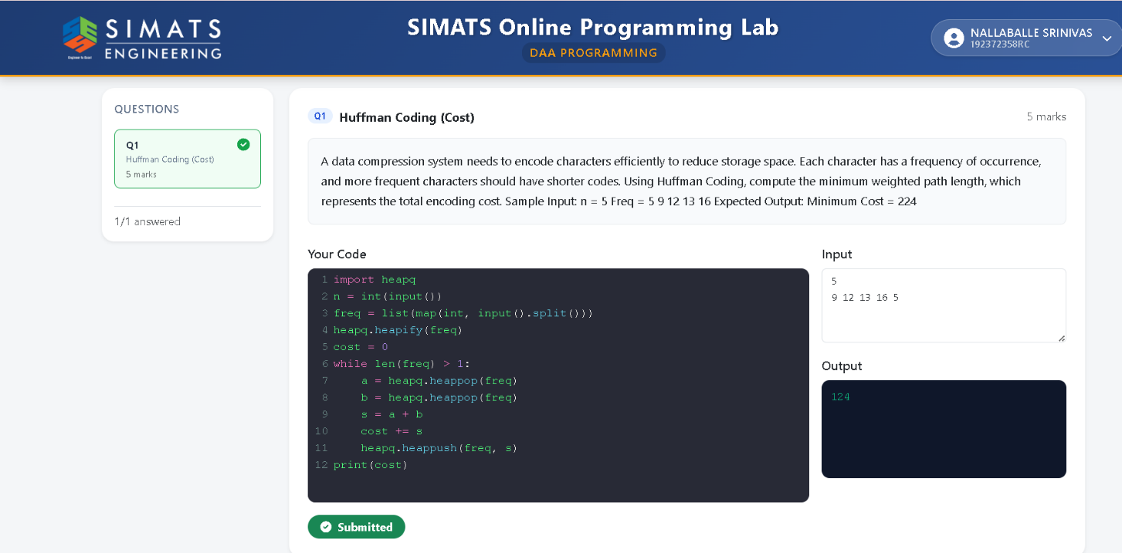

HUFFMAN CODING:

Huffman Coding is a lossless data compression technique used to reduce the size of data without losing any information. It was developed by David A. Huffman in 1952. The main idea of Huffman Coding is to assign shorter binary codes to characters that occur more frequently and longer binary codes to characters that occur less frequently.Huffman Coding uses a binary tree called a Huffman Tree. First, the frequency of each character is calculated. The characters are then arranged according to their frequencies. The two characters or nodes with the lowest frequencies are combined to form a new node. This process is repeated until a single root node is obtained. The left branch of the tree is generally assigned 0 and the right branch is assigned 1. The path from the root to each character represents its Huffman code.The major advantage of Huffman Coding is that it provides lossless compression, meaning the original data can be completely reconstructed after decompression. Therefore, Huffman Coding is an important and widely used technique in computer science and data compression.

